THN (The Healer Network) – Documentation

1. Introduction
The Healer Network (THN) is an online platform designed to connect users with professional healers for guidance, therapy, and wellness sessions. The platform enables users to easily find a healer, book an appointment, make secure online payments, and attend sessions via Google Meet—all in one place.
Users can:
- Browse healer profiles
- View healer expertise and specialties
- Select a suitable date and time
- Book appointments securely
- Attend sessions online from anywhere
Healers can:
- Manage their availability
- Accept or reject appointments
- Conduct personalized healing sessions in a secure and professional environment

Key Features
- Simple and smooth appointment booking
- Secure online payment system
- Private and reliable Google Meet sessions
- Easy communication between users and healers
The Healer Network is designed to create a trusted digital space where healing, guidance, and wellness services are accessible to everyone.

2. Super Admin Login Instructions
To access the Super Admin Panel, follow the steps below:
- Open the following URL in your browser:
http://thehealernetwork.com/superadmin
- You will be redirected to the login page.
- Use the following credentials:
  - Email: superadmin@gmail.com
  - Password: admin
Important Note:
For security reasons, credentials should be changed regularly. To update login details, please contact the system administrator.
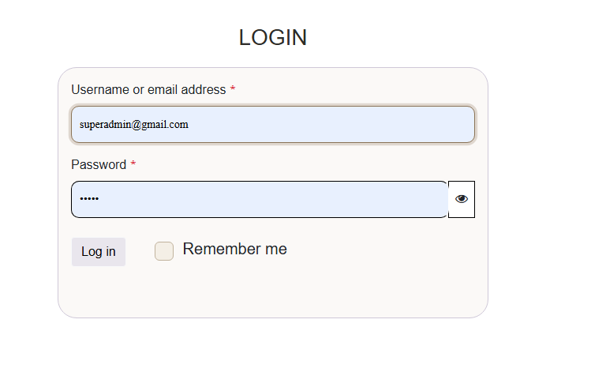
After logging in, you will be redirected to the Dashboard

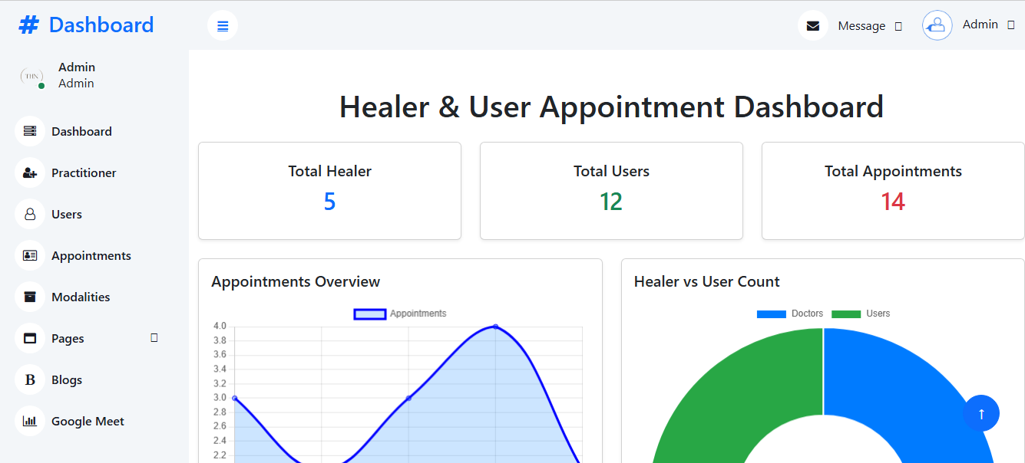

3. Admin Dashboard Overview
The Healer & User Appointment Dashboard serves as the main control panel for Admin and Super Admin users.
It provides:
- Overview of total healers and users
- Appointment statistics
- System activity summary
- Visual analytics for better decision-making

Healer Management Page
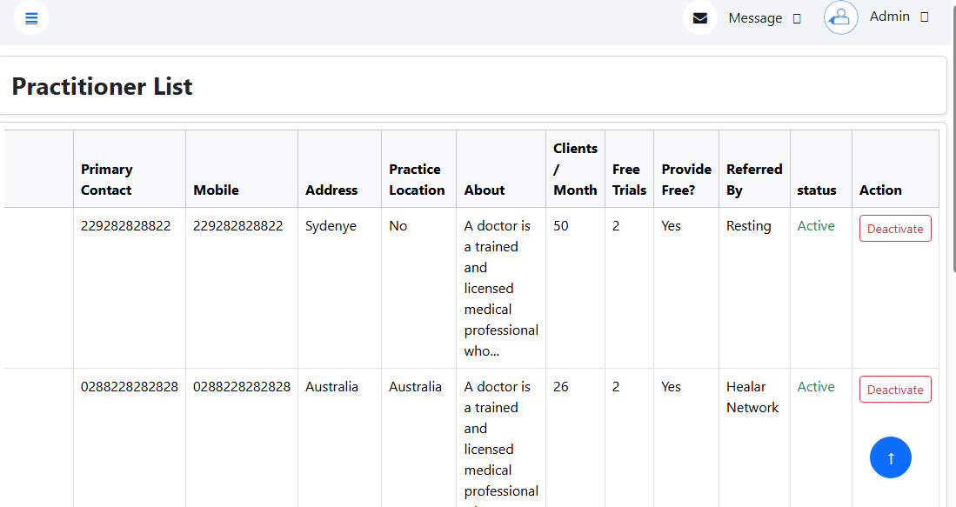

- Displays all registered healers in the system
- Newly registered healers appear here by default
- Admin approval is required before healers can access the Healer Dashboard
- Admin can activate or deactivate healer accounts

User Management Page
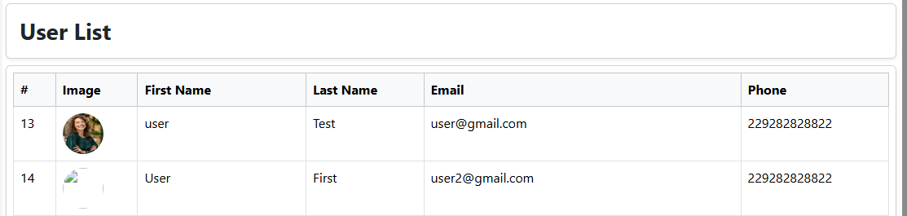

- Displays all registered users
- Allows admin to view user activity and appointment history

User & Healer Appointment Page
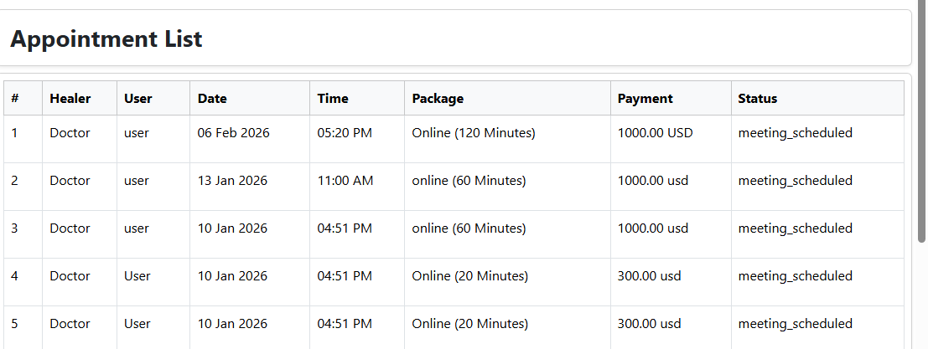
- Shows all appointments booked by users
- Displays assigned healers, appointment dates, and session status
- Used for monitoring and managing appointment flow

Modalities Management

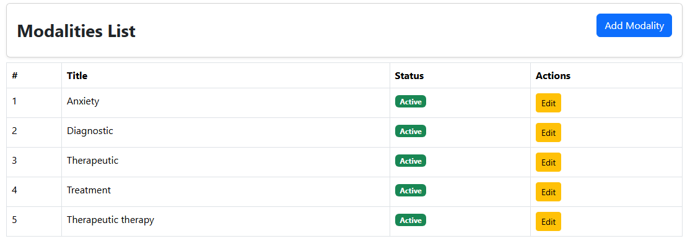
- Admin can add, update, or remove healing modalities
- Modalities define the types of healing services available on the platform

Contact Us Page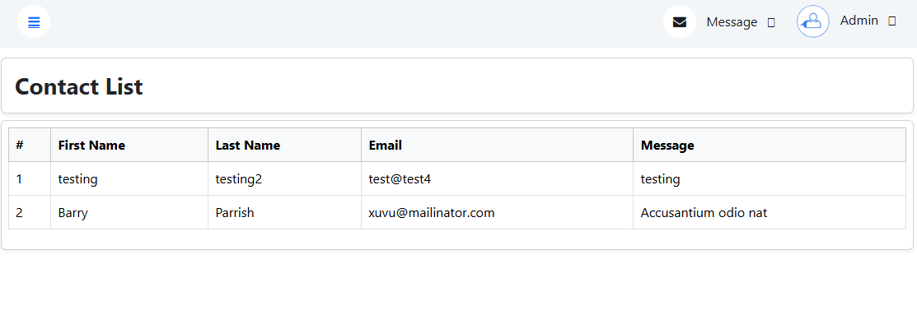
Displays all messages submitted via the “Contact Us” form
Admin can review and respond to user inquiries

Newsletter Subscription

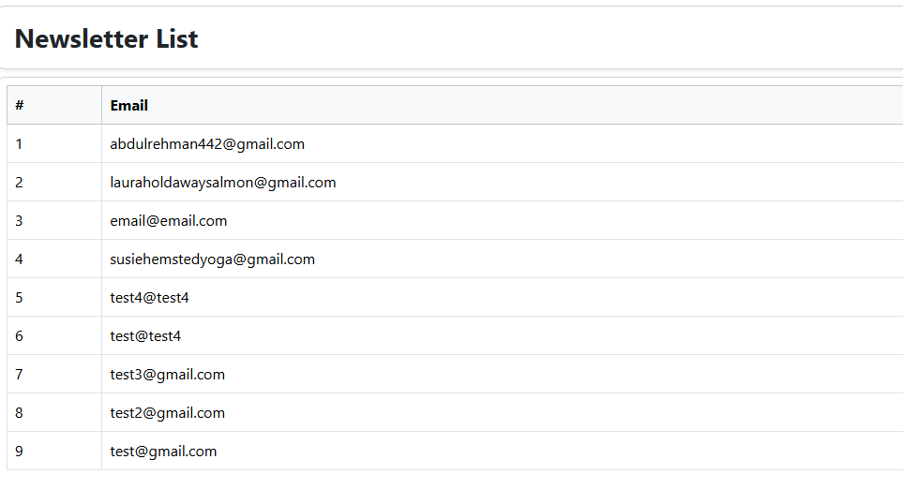
- Stores email addresses of all subscribed users
- Used for announcements, updates, and promotional emails

Blog Management
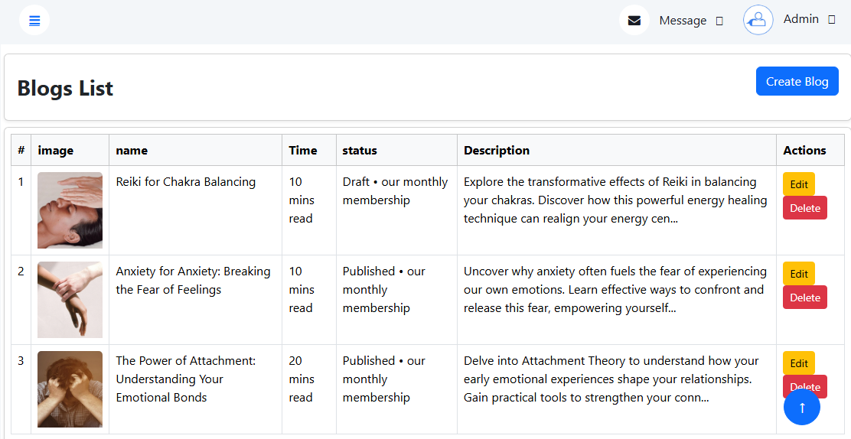
- Admin can create, update, and delete blog posts
- Blogs are displayed on the website for users

Google Meet Integration

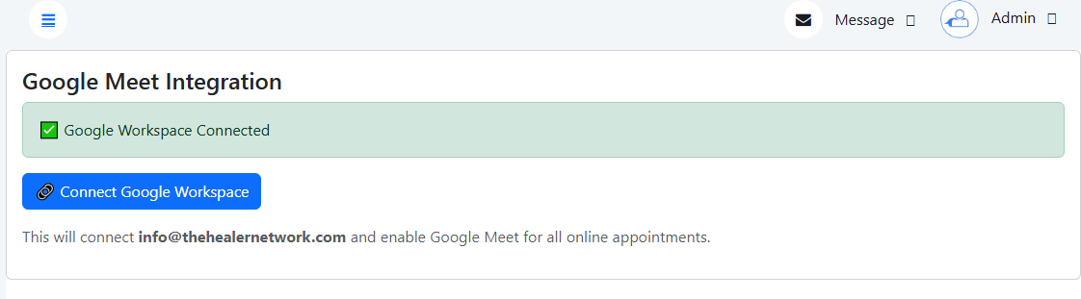
- Admin connects a Gmail account to enable Google Meet link generation
- Meeting links are automatically generated for appointments
- The same integration is used across the entire website for online sessions

